Examples of Anonymous/Authorless/Unknown Art?
The definition of anonymous is the unknown name or origin or something. Being anonymous means that the artist/author simply does not want their name on their work, or the origin of the piece of work is unknown (Dictionary).
The ICA’s Insider Art exhibition held in the August and early September of 2007 presented a selection of work by people in prisons and institutions organised by the Koestler Trust. Many of the artworks entered into the competition were anonymous. In fact, the third place prize went to an anonymous word titled ‘My Birds, My Family, My Friends’ (Finn, C. 2007).
Therefore, this example lies within the boundaries of anonymity due to the fact that artists entering into the competition can choose to be named along with their painting and not remain anonymous. Chesshyre wrote in a similar article the previous year, that ‘prize money of £32,500 [will be] parcelled in small amounts to encourage the maximum number of artists’ (Chesshyre, R. 2006). Here it becomes clear that it is down to the individual’s choice as to whether them as the artist receives credit for their work or not; they do not remain anonymous due to the artist being unknown or due to being forced to remain anonymous.
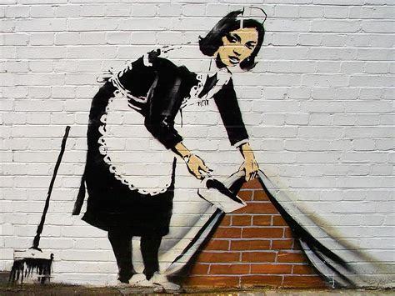
Banksy has a net worth estimated to be north of $20 million, however the true identity of the artist remains unknown but still hotly debated. Gioia claims in his article for ‘the Daily Beast’ that artists like Banksy ‘prefer obscurity over the perks of celebrity status’ (Gioia, T. 2016). Outside of the art world, Gioia also sites other examples of anonymity; novelist Elena Ferrante, Satoshi Nakamoto’s invention of Bitcoin and the masked attempts by artists such as Daft Punk.
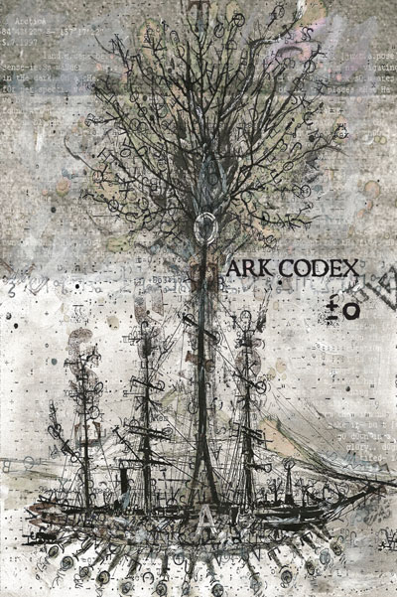
I feel that in the case of Banksy, the word anonymous is perhaps not appropriate as we know that the work of Banksy is by Banksy; he/she is the creator/maker/artist despite it not being their birth name. In contrast, the artist who painted ‘My Birds, My Family, My Friends’ in the Koestler Trust competition is truly unknown as there is not even an alias that can be attributed to the creator. By extension of that, I suggest that he/she did not receive the prize money for coming third in that year’s competition. Therefore, I see the name Banksy as an extension of the true artist’s identity as they haven’t truly decided to remain anonymous, where he/she would live without the $20 million, where even the name Banksy does not exist.
‘Books as Authorless Art Objects’ is an article on creators.vice.com by Blake Butler who holds an electronic email interview with a publisher Derek White concerning ‘Ark Codex ±0’ an authorless ‘colour print object…comprised of 144 full-colour images’ on deformed pages with text on ‘retelling…Noah’s Ark, mashed together with math…and blood’ (Butler, B. 2012). During the interview White claims that the book is like ‘looking up “dictionary” in a dictionary only to find it’s what you’re holding in your hands.’ He claims that whoever reads or looks at the book becomes the author as no one has the ‘authority over language, or even certain strings of characters or words’. White continues to say that Ark Codex ‘should be treated as a found object with no preconceived instructions on what to do with it’ (White, D. 2012).
I feel that it would be hard to argue that Ark Codex has an author as it becomes clear that the most interesting aspect of Ark Codex is trying to understand what it actually is. Thinking of the words author and maker, does the book have an author or does the thing have a maker. Whoever and whatever contributed to the thing that is Ark Codex is not just anonymous (as this primarily relates to a person) but is unknown. Whatever it does or does not have, it does have a publisher; a simple business head (and evident money maker) who represents Ark Codex. Due to the fact White suggests that it should be treated as a ‘found object’ does imply anonymity as the word ‘found’ kind of implies that the origin of the object remains a mystery. However, in a paradoxical way, if each user becomes an author of the object as also previously suggested by White in the interview, then does the object then have multiple authors or does each author own a completely different object?
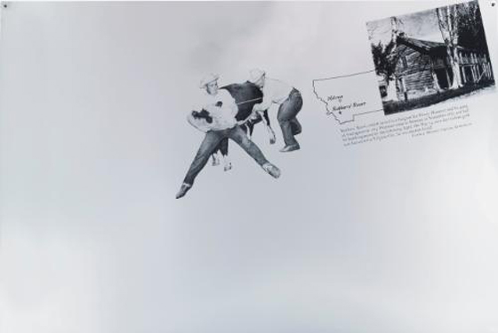
In an interesting case of authorless art, in 2011 at an art auction in America, Cady Noland’s ‘Cowboys Milking’ was put up for sale by the collector Marc Jancou. Jancou had paid $106,500 for the piece of work in 2011, and it was now estimated to sell for $250,000-$350,000. Martha Buskirk, author of the article for hyperallergic.com in 2013 writes that Noland inspected the piece before sale and insisted the auction house withdraw because ‘its current condition…materially differs from that at the time of its creation’. Following a legal battle, Noland ‘renounce[d] authorship of the work in its entirety’. (Buskirk, M. 2013)
Strictly speaking the definition of anonymous doesn’t completely relate to this case as Noland will always be known as the author or creator of the piece of work ‘Cowboys Milking’ before the work became legally authorless. Typically to be a piece of work attributed to anonymity we must not know the author. However, the part of the definition that relates to the author/creator not wanting to have their name on their work could be argued as relevant to the Noland case but it just occurs years after the making of the piece. The other cases of anonymous art/work we have looked at above are all anonymous from the outset whereas this in comparison becomes anonymous, it loses its original origin in favour of limbo and the unknown.
In order for something, whether it is a piece of art or not, to be authorless we must not know the author or the origin of it. Of the four examples above, I feel the most anonymous piece of work is the Ark Codex ±0 object as you truly cannot see any point of origin or have any tangible knowledge of any author other than the publisher that represents it, but even then they only own and collect revenue from the object’s success. There could be an argument made for the anonymous prisoner who won third place in the Koestler Trust competition being truly anonymous, but we do know that the origin of the painting was a person in a prison in 2007, and if great lengths were gone to, the author could probably be found. The same can be said Banksy and the Cady Noland Case. Whoever Banksy is, he or she is massively successful and to a degree is known as I argue an alias is an identity even if it isn’t your real name and so anonymity is a questionable issue here for me. Noland’s case can be seen as only legally authorless as we know she did actually make Cowboys Milking but she just has no legal authorship over the piece. The struggle to think of anything that is truly authorless or anonymous that isn’t purely natural for me is still ongoing, but I think Ark Codex is as close as you’re going to get at the moment.

References
Buskirk, M. (2013). Marc Jancou, Cady Noland, and the Case of the Authorless Artwork. [online] Hyperallergic. Available at: https://hyperallergic.com/97416/marc-jancou-cady-noland-and-the-case-of-an-authorless-artwork/ [Accessed 13 Dec. 2017].
Butler, B. (2012). Here Is a Book that Wrote Itself. [online] Vice. Available at: https://www.vice.com/en_us/article/bnymw8/here-is-a-book-that-wrote-itself [Accessed 13 Dec. 2018].
Chesshyre, R. (2006). The fine art of starting over. [online] the Guardian. Available at: https://www.theguardian.com/artanddesign/2006/sep/17/art [Accessed 11 Jan. 2018].
Finn, C. (2007). The power of anonymous art. [online] the Guardian. Available at: https://www.theguardian.com/artanddesign/artblog/2007/aug/21/thepowerofanonymousart [Accessed 13 Dec. 2017].
Gioia, T. (2016). Banksy, Daft Punk, Elena Ferrante: The New Cult of the Anonymous Artist. [online] The Daily Beast. Available at: https://www.thedailybeast.com/banksy-daft-punk-elena-ferrante-the-new-cult-of-the-anonymous-artist [Accessed 13 Dec. 2017].

